

Final Project Report – Programming Fundamentals
Department:
Department of Computer Science
Course:
Programming Fundamentals
Project Title:
Quizify

Submitted By:
Amna Saad (25K-0615)
Roshni Vikram (25K-0907)
Submitted To:
Ms Kinza Mushtaq
Semester:
Fall 2025
Date:
20th Nov 2025

Abstract:
Quizify is a console based application developed in the coding language C that presents the user with an optimized and productive way of learning. It offers the user to store, delete and edit flashcards. These flashcards are later used to run games. Additionally it also allows the user to set a goal time to complete their quizzes and displays a message if the user was able to complete it within the time limit. It uses the fundamentals of c programming to handle the storing, editing and deleting, struct arrays are used with the further help of decision structures and loops. It also utilizes the use of various in built libraries provided by the c language itself, some of them being (<stdlib.h>, <time.h>). It highlights the effective use of flashcards to review and enhance your learning experience.
1.Introduction:
There is always the risk of losing your written flashcards/notes if you opt for the traditional way of note taking, furthermore this was is way more time consuming, Quizify aims to resolve all of these hassles by offering an application in which you can store and modify your flashcards digitally to suit your needs, providing the user with a flexible and secure mode of learning. It provides a simple interface to store and use flashcards in games.
2.Objectives:
- To give the user the option to store, delete and edit flashcards
- To integrate those flashcards in games such as lightning mode and battle mode.
- Using rand() function to generate and shuffle questions
- To inform the user if they won or lost
- Displaying if they achieved the goal time they set for themselves
- Achieving a menu driven , user friendly interface
- Reinforcing programming concepts by using struct array, decision statements, loops and functions for games.

3.System Design
System overview:
How the program flows:

- Start
- Displays Main Menu (1. Store, 2. Delete, 3. Edit, 4. Play a game, 5. Exit)
- Executes as per the requirement of the user
- End

Algorithm:

- Starting the program displaying choices to the user, whether they want to store, edit, delete flashcards, play a game or simply exit the program.
- In the edit and delete feature it is initially checked if flashcards of that particular subjects exist in order to delete or edit them , the program exits itself back to the main menu if no flashcards exist.
- Similarly in the play a game feature a minimum of five flashcards should exist of that particular difficulty level that the user has entered for any game to run.
- In the lightningMode game, 10 seconds are dedicated for each question. If the user answers correctly then he gains 10 points. If he answers incorrectly then hes asked if he wants to store notes.
- We are going to loop through 5 questions, (until asked is 5)
- Record the time to implement the 10 second rule.
- If timeTaken is greater is 10, then reset the streak. Mark the question as incorrect and show the correct answer.
- If the answer is correct then the marks the answer as correct and add 10 points to the score. Increment the streak too and update the maxStreak if needed.
- If the answer is incorrect then reset streak and show the correct answer, ask the user to store notes. If yes then store the note in notes[wrongCount].
- After the loop ends, display the final score and max streak.
- For each incorrect answer, display the question and if a note was saved..display that too.
- In the battleMode game, the user face off against the enemy in a five questions.
- Both the user and the enemy start with 60 HP
- Incase the user answers correctly then the user can damage 15 points from the enemies HP(Health points).
- If the user answers incorrectly then the HP of user will be damaged by 15 points.
- You are also given a goal time optionally. The game records the time for the whole quiz.
- If both hp reaches 0, then it’s a tie. If your hp is 0 then enemy wins. If enemy hp is 0, you won. If neither hp is 0 after 5 questions, the battle ends without a clear winner.
- Revision and notes feature is also implemented in the code.
- In the TowerMode game, A tower is being build for 4 floors and 3 questions are asked from the user. When the user answers correctly, +1 floor is done to the tower. When user answers incorrectly, the tower height is cut in half.
- The loop exits when the tower height becomes 4 as it started from 0 making the floors 4 AND for the questions being asked are 3 questions.
- The questions will appear randomly and may repeat.
- Time feature is implemented too.
- ELSE the user doesn’t win as he couldn’t reach 4 floors.
- Revision and notes feature is also implemented in the code.

Input & output:
The user stores the questions and their answers, choosing suitable difficulty level for these questions. The user also tells the number of questions they want to store in the flashcards. Moreover, two function takes the goal time and all three games/functions input a list of all flashcards having same difficulty level(difficultyArr) and the number of flashcards stored in difficultyArr(difficultyCount). It also stores the notes.
For the output, this program doesn’t have one specified output. It can vary according to the questions stored, the answers given and the difficulty level. This program does display notes and questions that were stored before. It also prints time taken for battleMode and towerMode, and prints the streaks for lightningMode.

4. IMPLEMENTATIONS:

Key Features:
• Storing , editing and deleting flash cards
• Storing the difficulty level for each question
• Using flashcards for quizzes of the same difficulty level
• Setting goal time for the game battle mode which displays if the player won and if the goal was achieved
• Reviewing questions answered wrong
• Answering questions in a time limit
• Checks for inputs that might be invalid
- maintaining and displaying a streak count in the game lightning mode

Code snippets:
Time feature(battleMode game and towerMode game):
printf("Enter your goal time in seconds, if you do not want to set any, type in 0: ");
scanf("%d", &goalTime);
time_t start= time(NULL);
time_t end = time(NULL);
int timeTaken = end - start;
if (timeTaken <= goalTime && goalTime!=0) {
printf("And you completed it within the goal time of %d seconds!\n", goalTime);
} else {
printf("But you took longer than your goal time (%d seconds).\n", goalTime);
}
Notes storing and revision feature(All games):
//when the answer is incorrect
wrongQ[wrongCount] = difficultyArr[index];
printf("Do you want to save a note? (y/n): ");
scanf(" %c", &noteChoice);
if(noteChoice == 'y'){
printf("Enter your note: ");
scanf(" %[^\n]", notes[wrongCount]);
}
wrongCount++;
}
//At the end of each game we make the user review the incorrect answers
if(wrongCount > 0){
printf("\nReview Incorrect Questions:\n");
for(i = 0; i<wrongCount; i++){
printf("%d) %s\n",i + 1, wrongQ[i].question); //revision mode(displaing previous wrong questions
if(strlen(notes[i])>0)printf(" Note: %s\n",notes[i]); //displaying the saved notes for each question, if saved
}
}
Streak feature(lightningMode game):
else if(strcmp(answer, difficultyArr[index].answer) == 0){ printf("Correct!+10 points\n"); score+=10;
streak++;
if(streak > maxStreak)
maxStreak = streak; //streak feature
}printf("Max Streak: %d\n", maxStreak); //print the maxStreak

Sample output:
WELCOME TO QUIZIFY
Store Flashcards to start playing fun games!
Do you want to
1 – Store flashcards
2 – Delete a flashcard
3 – Edit a flashcard
4 – play a game
5 – exit
1

Enter the number of questions you want to input right now: 10
What subject of flashcards do you want to access:
(1:Maths, 2:Science, 3:GeneralKnowledge)
1

Enter your question: 2+2
Enter the answer to the question: 4
Enter the difficulty level of this question: 1
Enter your question: 1+1
Enter the answer to the question: 2
Enter the difficulty level of this question: 1
Enter your question: 3+1
Enter the answer to the question: 4
Enter the difficulty level of this question: 1
Enter your question: 2+0
Enter the answer to the question: 2
Enter the difficulty level of this question: 1
Enter your question: 3+1
Enter the answer to the question: 4
Enter the difficulty level of this question: 1
Enter your question: 4+9
Enter the answer to the question: 13
Enter the difficulty level of this question: 1
Enter your question: 2+9
Enter the answer to the question: 11
Enter the difficulty level of this question: 1
Enter your question: 1+5
Enter the answer to the question: 6
Enter the difficulty level of this question: 1
Enter your question: 1+8
Enter the answer to the question: 9
Enter the difficulty level of this question: 1
Enter your question: 2+6
Enter the answer to the question: 8
Enter the difficulty level of this question: 1
Do you want to
1 – Store flashcards
2 – Delete a flashcard
3 – Edit a flashcard
4 – play a game
5 – exit
2
Which subject do you want to delete from? (1:Maths, 2.Science, 3:GeneralKnowlegde)
1
Displaying maths flashcards
Questions 1 2+2
Question 2 1+!
Question 3 3+1
Question 4 2+0
Question 5 3+1
Question 6 4+9
Question 7 2+9
Question 8 1+5
Question 9 1+8
Question 10 2+6
What question do you want to delete: 6
Deleted successfully
Do you want to
1 – Store flashcards
2 – Delete a flashcard
3 – Edit a flashcard
4 – play a game
5 – exit
4 (now the menu would display again for the games after asking for the no of qs and difficulty level.
The game begins: LIGHTNING ROUND  You have only 10 seconds per question.  The number of questions will be 5  Correct answers will give you +10 points, wrong or slow answers would result in no points hehehe.  Question 1: 1+8  Type your answer: 9  Correct!+10 points  Question 2: 1+5  Type your answer: 6  Correct!+10 points  Question 3: 3+1  Type your answer: 4  Correct!+10 points  Question 4: 2+2  Type your answer: 5  Wrong! Correct answer: 4  Do you want to save this note? (y/n): n  Question 3: 3+1  Type your answer: 4  Correct!+10 points  LIGHTNING MODE RESULTS  FINAL SCORE  Total Score: 30  Max Streak: 2  Review Incorrect Questions:  4) 2+2 | -----BATTLE MODE START-----  Alloted time to complete 5 questions is 40 seconds  Question1) 2+2  Your answer: 4  Correct! , the enemy is down 15hp  HP of enemy : 45  HP of player : 60  Question2) 4+10  Your answer: 14  Correct! , the enemy is down 15hp  HP of enemy : 30  HP of player : 60  Question3) 3+3  Your answer: 6  Correct! , the enemy is down 15hp  HP of enemy : 15  HP of player : 60  Question4) 2+2  Your answer: 4  Correct! , the enemy is down 15hp  HP of enemy : 0  HP of player : 60  BATTLE RESULTS  You won!! The enemy is defeated.  And you completed it within the goal time of 40 seconds!
TOWER MODE Goal: Build a tower of height 4!
Correct answer = +! Floor
Wrong answer = tower height is CUT IN HALF
You must finish

5. Testing and Results:
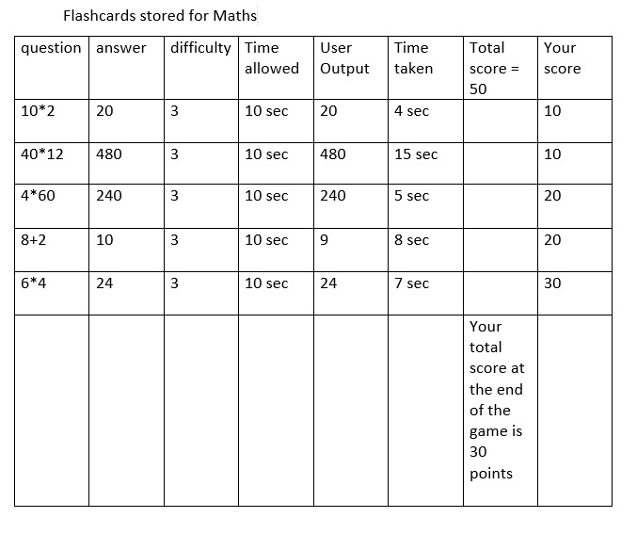 | 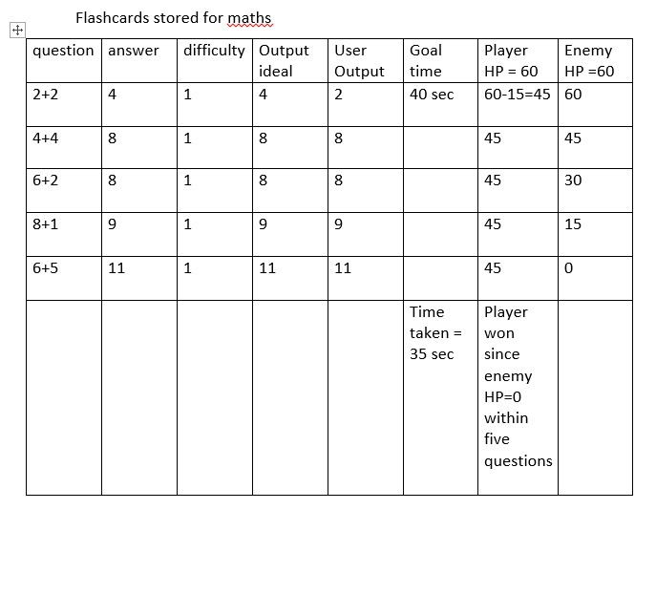

6. Conclusion

Limitations
Quizify provides the user with a solid base to further develop advanced features
Some of its limitations include:
1) It does not offer permanent storage. Whenever the program stops running the previous flashcards stored are lost.
2) It has limited subject options as in this program it only stores three which include maths, science and general knowledge.
3) The program does not support multiple player games. It is based solely for one user.
4) Lastly it does not include graphical interface , it is a console based application.

Future enhancements:
1) The integration of a graphica interface to make the application more engaging
2) The addition of storage of data in files to offer the solution for temporary storage.
3) Adaptive learning systems, the user gets repeated questions of the questions he/she attempted wrong previously.

References:
- https://vardhaman.org/wp-content/uploads/2021/03/CP.pdf
- https://www.programiz.com/c-programming
- Lab manuals

